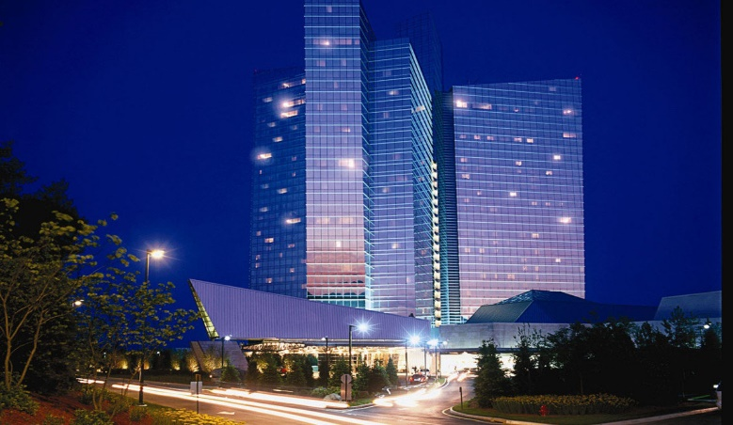

**2024 NEAFC CONFERENCE / EXPO**

**OCTOBER 16-18, 2024**

**MOHEGAN SUN EARTH EXPO CENTER**

**SCHEDULE:**

* Wednesday October 16, 2024

Expo floor opens at 17:00 – 20:00

Vendor appreciation 18:00 – 20:00 (beer/wine and apps)

Presentation on Neris Information

* Thursday October 17, 2024

Opening ceremony w/IAFC Josh Waldo 08:00 – 08:45

Exhibit floor opens 09:00 – 16:00

Professional Development programs 09:00 – 11:00

Presentation on Neris system 11:30

Professional Development programs 13:00 – 15:00

Annual Memorial Service 16:30 – 17:30

Annual Membership Meeting 17:30 – 18:30

Presidential Celebration 18:30 - ????

* Friday October 18, 2024

Exhibit floor open 09:00 – 15:00

Professional Development programs 09:00 – 15:00

**PROFESSIONAL DEVELOPMENT CLASSES**

Thursday 09:00 – 11:00

* How Mass Gathering Events can Aid Your Response to an Active Shooter Event by Chief John Oates
* Lithium – ION Battery Fire Awareness by Vermont Fire Academy
* Fit for Duty by McNeil & Company
* Employee Development by Chief Michael O’Brian
* NERIS: Changing Data – driven decision making by Chief Tom Jenkins

Thursday 13:00 – 15:00

* Community Risk Reduction: The Intersection of Tradition + Transformation by Karen Berard-Reed and Chelsea Rubadou
* Ten Fingers/Ten Toes : How to survive fire chief-ing in 2024 by Chiefs John Oates and Tom Jenkins
* Beyond the Sirens: Rethinking EmergencyResponse by McNeil & Company
* Developing the EVR by Chief Michael O’Brian

Friday 09:00 – 11:00

* Preparing for the Promotion by Chief William Perez
* What puts the A in AI by Chief John Oates
* Lithium -ION Battery Fire Awareness by Vermont Fire Academy
* Developing the EV Response by Chief Michael O’Brian

**TICKET INFORMATION**

* Wednesday Exhibit Floor and Vendor Appreciation Reception - $10
* Thursday Professional Development Programs and EXPO - $125
* Friday Professional Development Programs and EXPO - $75
* General Admission Exhibit Floor Only – Thursday - $10
* General Admission Exhibit Floor Only – Friday - $10
* General Admission Exhibit Floor Only – 2 Day Pass - $18
* Full Conference Package (Wednesday – Friday) $200

**MORE INFORMATION ON NEWENGLANDFIRECHIEFS.ORG**